CORRELATION ANALYSIS
Class Activity

Name: Edrin J S
Register Number: 192524041
Course Code: DSA0504
Date: 07-08-2026

1. Load the CSV and Scatter Plot
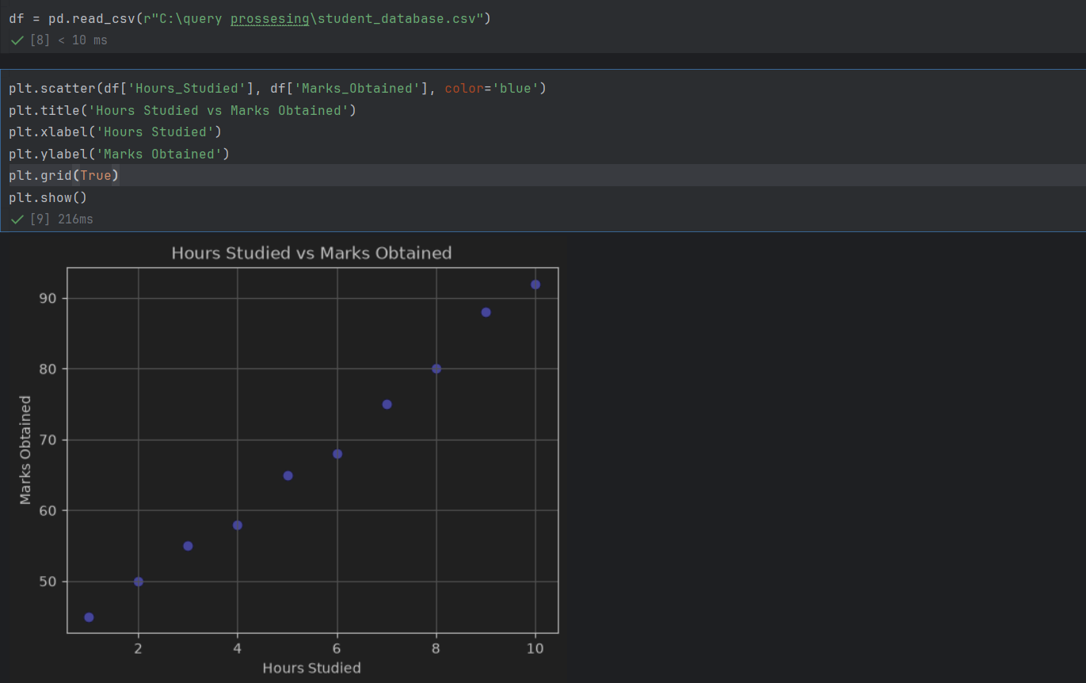

2. Extracting X and Y, Computing the Sums
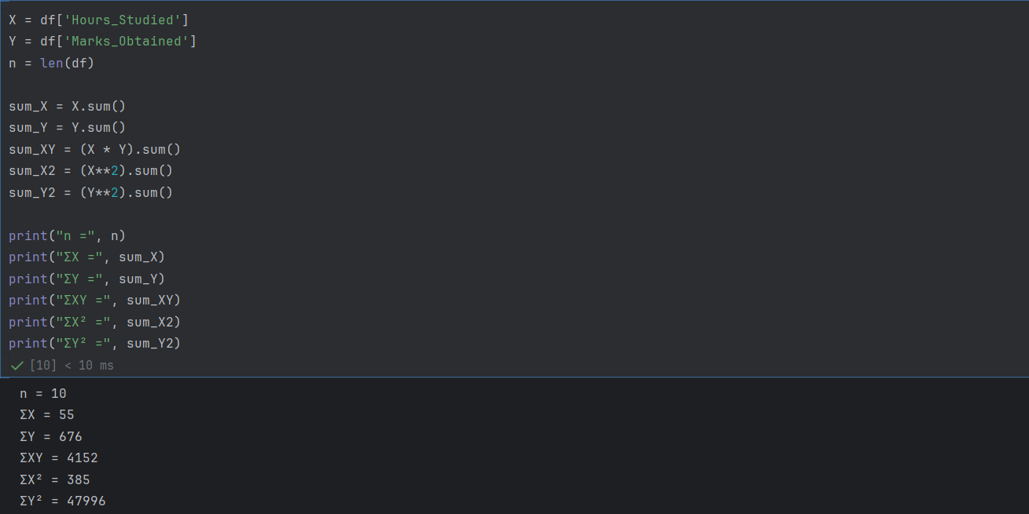

3. Applying Pearson's Formula and Verification
